Program 1:

#include <iostream>

using namespace std;

// Function template to swap two elements

template <class T>

void swap_numbers(T& x, T& y) {

T tmp;

tmp = x;

x = y;

y = tmp;

}

int main() {

int a, b;

a = 10, b = 20;

cout<<"a and b before swap - "<<"a = "<<a<<" b = "<<b<<endl;

swap_numbers(a, b); //int swap

cout<<"a and b after swap - "<<"a = "<<a<<" b = "<<b<<"\n\n";

float c, d;

c = 10.34, d = 20.54;

cout<<"c and d before swap - "<<"a = "<<c<<" b = "<<d<<endl;

swap_numbers(c, d); //float swap

cout<<"c and d after swap - "<<"a = "<<c<<" b = "<<d<<"\n\n";

char e, f;

e = 'x', f = 'y';

cout<<"e and f before swap - "<<"a = "<<e<<" b = "<<f<<endl;

swap_numbers(e, f); // char swap

cout<<"e and f after swap - "<<"a = "<<e<<" b = "<<f<<endl;

return 0;

}

Output:

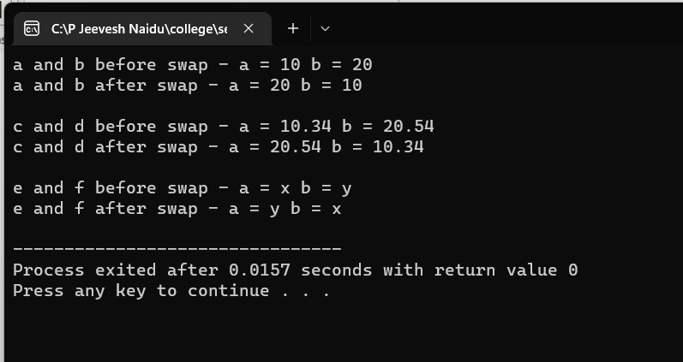

Program 2:

#include<iostream>

using namespace std;

template<class T>

class vector {

T *v;

int size;

public:

vector(int m) { // parameterized constructor to create NULL vector

size=m;

v=new T[size];

for(int i=0;i<size;i++)

v[i]=0;

}

void create() {

for(int i=0;i<size;i++) {

cout<<"v["<<i<<"] = ";

cin>>v[i];

}

}

void modify() {

int pos;

cout<<"enter position to make changes :";

cin>>pos;

cout<<"Enter new Value :";

cin>>v[pos-1];

}

void display() {

int i;

cout<<"(";

for(i=0;i<size-1;i++) {

cout<<v[i]<<",";

}

cout<<v[i]<<")\n";

}

};

int main() {

int size;

cout<<"enter size of vector: ";

cin>>size;

cout<<"Enter the vector\n";

vector<int> v1(size); //creates int vector

v1.create();

v1.display();

v1.modify();

v1.display();

cout<<"-----------------------\n";

cout<<"Enter the vector\n";

vector<float> v2(size); //creates float vector

v2.create();

v2.display();

cout<<"-----------------------\n";

cout<<"Enter the vector\n";

vector<char> v3(size); //creates char vector

v3.create();

v3.display();

return 0;

}

Output:

